***WHY***

***Why does rapport matter?***

***WHAT***

***What is rapport?***

Growth & change in their teaching

“fosters this growth”

“more enthusiastic about going back to the classroom”

“feel like they can… experiment or try new things”

Professional Rapport

Personal Rapport

[](http://creativecommons.org/licenses/by-nc/4.0/)

Empathy

Connection

“A Human need”Reassurance in place of anxiety and nervousness

Trust.

A safe space despite vulnerability

Openess in discussions

C

“speak freely”

“Sharing openly”

“helps you to know the person”

***Way of being***

***Unspoken***

?Rapport?

***SO WHAT***

***How can we mentor?***

|  |
| --- |
| Mutual Respect |

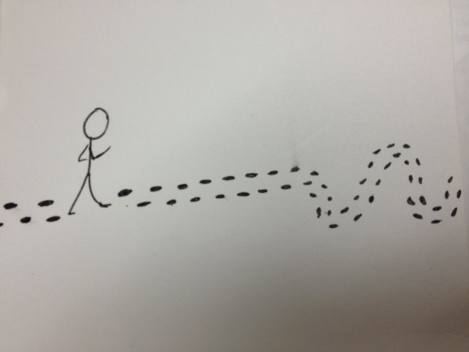

Collegiality

Trust/ Trustworthiness

Role Models and Mentors

This work is licensed under a [Creative Commons Attribution-NonCommercial 4.0 International License](http://creativecommons.org/licenses/by-nc/4.0/). We hope you will distribute, tweak and build upon this information in your own non-commercial work. Please cite us: Kim West & Carolyn Hoessler (2014). Rapport Building as Educational developers. EDC conference, Calgary. **Contact us**: kim.west@usask.ca or carolyn.hoessler@usask.ca

***WHEN***

***Changes in rapport building with experience across ED career***

**Rapport Building as Educational Developers**

***(Summary based on the combined responds from 20 interviews)***

↑ confidence

↑ self-awareness

↑comfort, ease

Focus on person

Focus on growth

Focus on ED actions

Meet where they’re at to address their goals

Asking Questions, coaching, facilitating exploration of options

Encouraging and supporting

Connect to learn their goals & context

***But…***

*varies across individuals:*

* *Straight to the point vs. small chat about life*
* *Quiet vs. energetic speakers … etc.*

*varies by purposes, contexts, course, discipline…*

***HOW***

***How do we build rapport?***

A. Case Study of actual consultation. Discuss what would you do?

B. Sit in (pre-meeting to discuss request, observe, maybe be invited to add, debrief)

C. “Staged” consultation with a frequent visitor who then provides feedback

D. Own consultations, colleagues doors open for 2nd opinion or unloading